**PIZZA SALES SQL QUERIES**

**KPI’S:**

1)SELECT SUM(total_price) AS Total_Revenue from pizza_sales

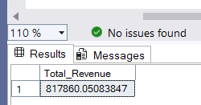

2) select sum(total_price)/ COUNT(DISTINCT order_id) AS Avg_Order_Value from pizza_sales

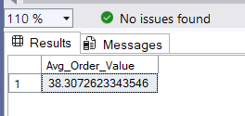

3) select sum(quantity) AS Total_Pizza_Sold from pizza_sales

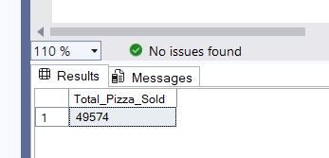

4) select COUNT(DISTINCT order_id) AS Total_Orders from pizza_sales

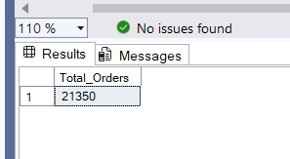

5) select CAST(CAST(SUM(quantity) AS DECIMAL(10,2))/

CAST(COUNT(DISTINCT order_id) AS DECIMAL(10,2))

AS DECIMAL(10,2)) AS Avg_Pizza_Per_Order

from pizza_sales

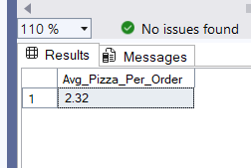

**Chart:**

1) select DATENAME(DW,order_date) AS Order_day,

COUNT(DISTINCT order_id) AS Total_Orders

from pizza_sales

GROUP BY DATENAME(DW,order_date)

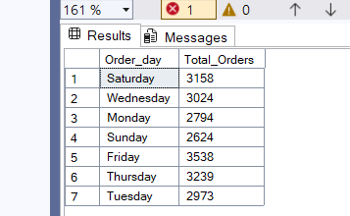

2) SELECT DATEPART(HOUR,order_time) AS Order_Hour,

COUNT(DISTINCT order_id) AS Total_Orders

from pizza_sales

GROUP BY DATEPART(HOUR,order_time)

ORDER BY DATEPART(HOUR,order_time)

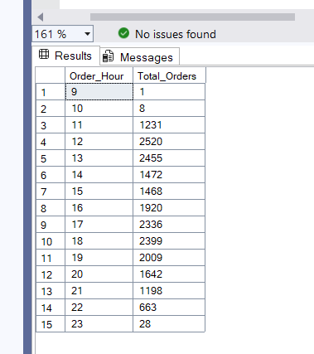

3) SELECT pizza_category, CAST(SUM(total_price) AS DECIMAL(10,2)) as total_revenue,

CAST(SUM(total_price) * 100 / (SELECT SUM(total_price) from pizza_sales) AS DECIMAL(10,2)) AS

PCT FROM pizza_sales

GROUP BY pizza_category

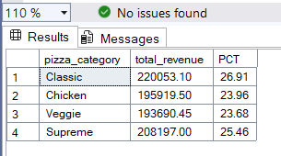

4) SELECT pizza_size, CAST(SUM(total_price) AS DECIMAL(10,2)) as total_revenue,

CAST(SUM(total_price) * 100 / (SELECT SUM(total_price) from pizza_sales) AS DECIMAL(10,2)) AS PCT

FROM pizza_sales

GROUP BY pizza_size

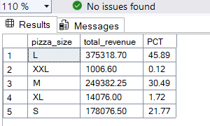

5) SELECT * from pizza_sales

select pizza_category, sum(quantity) as Total_Pizza_Sold

from pizza_sales

GROUP BY pizza_category

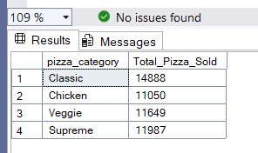

6) SELECT TOP 5 pizza_name, sum(quantity) as Total_Pizza_Sold

from pizza_sales

group by pizza_name

order by Total_Pizza_Sold desc

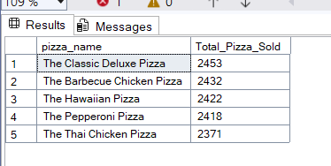

7) SELECT TOP 5 pizza_name, sum(quantity) as Total_Pizza_Sold

from pizza_sales

group by pizza_name

order by Total_Pizza_Sold Asc

